**Project Write-up**

DESCRIPTION

**Project Objective:**

As a developer, write a program to find the longest increasing subsequence.

**Background of the problem statement:**

As a developer, write a Java code to find the longest increasing subsequence from a list of random numbers.

**Longest Increasing Subsequence.**

**package** Longest_Increasing_Subsequence;

**class** LIS {

**static** **int** *max_ref*; // stores the LIS

**static** **int** _lis(**int** arr[], **int** n)

{

**if** (n == 1)

**return** 1;

**int** res, max_ending_here = 1;

**for** (**int** i = 1; i < n; i++) {

res = *_lis*(arr, i);

**if** (arr[i - 1] < arr[n - 1]

&& res + 1 > max_ending_here)

max_ending_here = res + 1;

}

**if** (*max_ref* < max_ending_here)

*max_ref* = max_ending_here;

**return** max_ending_here;

}

**static** **int** lis(**int** arr[], **int** n)

{

*max_ref* = 1;

*_lis*(arr, n);

**return** *max_ref*;

}

**public** **static** **void** main(String args[])

{

**int** arr[] = { 10, 22, 9, 33, 21, 50, 41, 60 ,70 ,80 };

**int** n = arr.length;

System.***out***.println("Length of lis is " + *lis*(arr, n) + "\n");

}

}

**Output:**

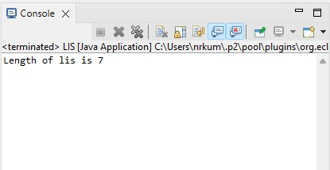

Pushing the code to your GitHub repositories

* Open your command prompt and navigate to the folder where you have created your files.

**cd <folder path>**

* Initialize your repository using the following command:

**git init**

* Add all the files to your git repository using the following command:

**git add .**

* Commit the changes using the following command:

**git commit . -m “Changes have been committed.”**

* Push the files to the folder you initially created using the following command:

**git push -u origin master**